TREE SPANNERS
LEIZHEN CAI AND DEREK G. CORNEIL
SIAM J. DISC. MATH, Vol8, No. 3,pp. 359-387
Abstract
1.Introduction
Definition
Minimal, minimum, optimal t-spanner : A t-spanner H is a minimal t-spanner if no subgraph of H is a t-spanner of G, a minimum t-spanner if it has the least number of edges among all t-spanners of G and an optimal t-spanner f H has the least weight among all t-spanners of G.

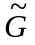 and G : For a directed graph (digraph) G = (V, A; w), we use G = (V, E; 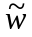) to denote its underlying undirected graph, i.e., xy E iff either (x,y) A or (y,x) A or both, and
(x,y)= {w((x,y)) if(x,y) A,(y,x) A,
w((y,x)) if(y,x) A,(x,y) A,
min{w((x,y)),w((y,x))}if(x,y), (y,x) A}
A vertex x reaches vertex y(y is reachable from x) in G if there is a directed {x, y}-path in G. It follows that 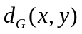 = if y is not reachable from x in G.)
Quasi tree and quasi-tree t-spanner: A quasi tree of G is a spanning subgraph T such that 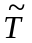 is a tree; T is a quasi-tree t-spanner if it is a t-spanner of G.
Other definition: For a connected graph, a k-cut is a set of k vertices whose deletion disconnects the graph. A graph G is nonseparable if it has no I-cut and triconnected if it has no k-cut for k ,1. A block of a graph is a maximal nonseparable subgraph, and a triconnected component of a graph is a maximal triconnected subgraph. A vertex is universal if it is adjacent to all other vertices of the graph. An edge e is a binding edge if its two ends form a minimal cut set. Two disjoint subgraphs S and S' of G are fully joined if every vertex in S is adjacent to every vertex in S'. A star is any complete bipartite graph 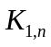 with n 1.

THEOREM I.I. Let H be a spanning subgraph of a weighted graph G == (V, E,w). The following statements are then equivalent:
(1) H is a t-spanner of G (i.e., 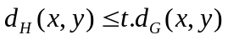 for every pair x,y V)
(2) For every edge xy E,
(3) For every edge xy E\E(H), 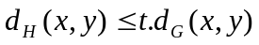.
(4) For every edge xy E, 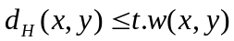.
(5) For every edge xy E\ E(H), .
Observation 1.2. Let F be a t-spanner of G and H be a k-spanner of F. Then H is a kt-spanner of G.
Observation 1.3. For any k > 1,H = {V,E';w} is a t-spanner of G = (V,E;w) iff H' = (V, E'; w') is a t-spanner of G' = (V, E, w'), where w'(e) = k . w(e) for every eE.
Observation 1.4. Let T be a spanning tree of a graph G. Then T is a tree t-spanner of G iff for every block H of G, T H is a tree t-spanner of H.
Observation 1.5. Let H be a spanning subgraph of an unweighted graph G. Then H is a f-spanner iff H is a 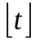-spanner.
2.Verifying a tree t-spanner
THEOREM 2.1. Let D and G be directed and undirected weighted graphs, respectively. Let S and T be spanning trees of D and G, respectively. Let Q be a quasi tree of D. Then the following problems can be solved in 0(m) time:
(a) Determine the stretch index of T.
(b) Is S a tree spanner? If it is, determine its stretch index.
(c) Is Q a quasi-tree spanner? If it is, determine its stretch index.

ALGORITHM VERIFICATION(G, T, t){Verify if T is a tree t-spanner of G.}
Input: A graph G, a spanning tree T and a positive number t;
Output: "Yes" if T is a tree t-spanner; "No" otherwise.
begin
1. Arbitrarily choose a vertex r as the root of T;
2. Compute a label label(x) for each vertex x of T;
3. Compute LCA(x, y) for every nontree edge xy of G',
4. for each nontree edge xy do
begin
4.1. Compute 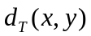by using the labels of x, y and LCA(a;, y),
4.2. if > t . w(xy) then output "No" EXIT;
end;
5. output "Yes";
end.

By statement (5) of Theorem I.I, we note that the stretch index of T equals
2.2Undirected case
Since
And

Hence
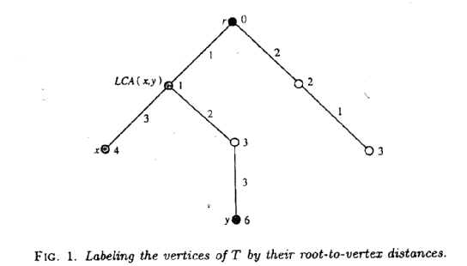
2.3 Directed case:
Definition: Arbitrarily choose a vertex r in 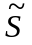 as the root of . An edge of S, where x is an ancestor of y, is a forward edge if (x, y) is an arc of S and a backward edge if (y, x) is an arc of S. For an arbitrary vertex x in S, let P(x) be the unique (r, x)-path in S.
Label x by a triple (b(x),f(x),l(x)), where
b(x) is the number of backward edges on P(x),
f{x} is the number of forward edges on P{x}, and
l(x) is the total weight of forward edges on P(x) minus the total weight of backward edges on P(x).
For any vertices x and y of S, x reaches y in S iff 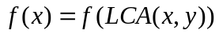
Distance: 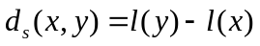
2.3 quasi-tree spanners
Definition:
Label x by (b(x),f(x),d(x),lb(x),lf(x)),where
- b(x),f(x),d(x) is the same with 2.2
- double edge: if both (x,y) and (y,x) are arcs in Q,the it calls double link.
- lb(x) is the total weight of arcs of Q corresponding to backward edges on P(x)
- lf(x) is the total weight of arcs of O corresponding to forward edges on p(x).
reachable: x reaches y iff
f(x)-f(LCA(x,y))=d(x)-d(LCA(x,y))
and
b(y)-b(LCA(x,y))=d(y)-d(LCA(x,y))
distance:
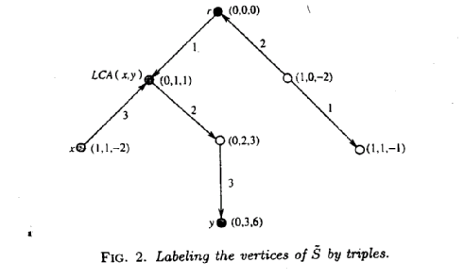
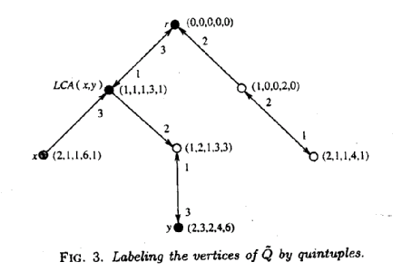
3. Tree spanners ..in weighted graphs
LEMMA 3.1. Let H be a 1-spanner of a weighted graph G. Then H is minimal iff 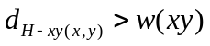 for every edge xy of H.
THEOREM 3.2. Let H be a minimal t-spanner of a weighted graph G, and let xy be an edge of G. Then the following statements are equivalent:
(1) Edge xy belongs to H.
(2) for every vertex z e V \ {x,y}, 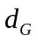(x,z) + da{z,y} > w(xy).
(3) Distance 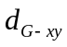(x,y) > w(xy).
Corollary 3.3 Every weight graph G has a unique minimal 1-spanner.
Corollary 3.4. For any weighted graph G, the following statements are
equivalent: (1) His a minimal 1-spanner of G.
(2) His a minimum 1-spanner of G. '
(3) H is an optimal 1-spanner ofG.
THEOREM 3.6. The minimum (or optimal) 1-spanner of a weighted graph can be found in O(mn+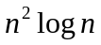) time.
Improved method:
THEOREM 3.7. The tree 1-spanner of a weighted graph G is a minimum spanning tree. Moreover, every tree 1-spanner admissible weighted graph contains a unique minimum spanning tree
THEOREM 3.8. The tree l-spanner of a weighted graph can be found in
O(mlog/3(m,n)) time, where /3(m,n) = 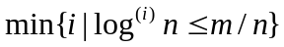 and 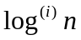 is defined by 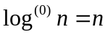,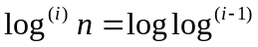 for i >=1.
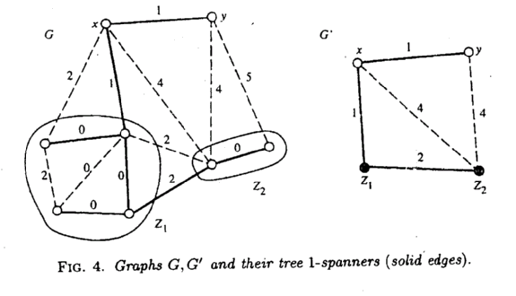

3.2 Np-completeness for t > 1.
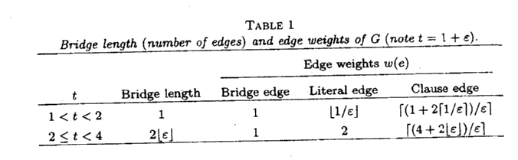 THEOREM 3.9. For any fixed rational number t > 1, it is NP-complete to determine whether a weighted graph contains a tree t-spanner, even if all edge weights are positive integers.
Proof:
- Take a vertex x and vertices U' =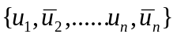, where n = |U|, and construct a star H centered at 3; by joining x to each vertex in [/'. Each vertex in U' is a literal vertex and each edge in H is a literal edge.
2. Create a new vertex c for each clause in C and add an edge between c and each of its three distinct literal vertices in H. These new vertices and edges are called clause vertices and clause edges, respectively.
3. Connect each pair 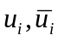 of literal vertices by a distinct path (whose length is specified in Table 1), called a bridge, to complete the construction of G. Each edge on the bridge is called a bridge edge.
4. For each edge e of G, assign it weight w() according to Table 1.
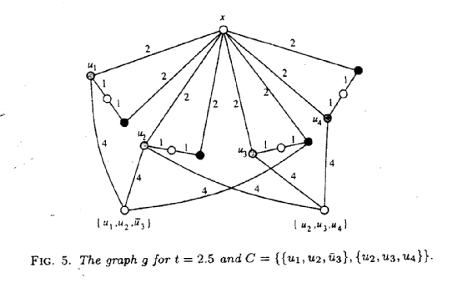4.The spanners in unweighted graphs
LEMMA 4.1. Let G be a nonseparable graph and T be an arbitrary
tree 2-spanner,of G. Then for every 2-cut {u, v} of G, uv E(T).
THEOREM 4.2. Let G be a nonseparable graph. Then a spanning tree T of G is a tree 2-spanner iff for each triconnected component H of G,T H is a spanning star of H.
THEOREM 4.4 (Bondy [7]). A graph G is tree 2-spanner admissible graphs iff each block H of G is either
- a triconnected graph with a universal vertex or
- an edge bonding (on edge e) of two tree 2-spanner admissible graphs where e is a tree edge in both graphs
Algorithm to find a 2-spanner graph:
The algorithm can be outlined as follows (details are left to the reader). First, find all blocks of G. Then, for each block, find all 2-cuts (if there is a 2-cut that does not induce a binding edge, then G contains no tree 2- spanner, by Lemma 4.1) and triconnected components. Put all binding edges in T.
Now, for each triconnected component H, find a spanning star containing all edges of H that have been put into T so far and put it in T (if such a spanning star does not exist, then G contains no tree 2-spanner by Lemma 4.1 and Theorem 4.2). Finally, if T is a spanning tree, then it is a tree 2-spanner; otherwise, G contains no tree 2- spanner. This algorithm can be implemented in hnear time by using the triconnected component-finding algorithm of Hopcroft and Tarjan and standard techniques.
THEOREM 4.5. A tree 2-spanner (if it exists) of a graph can be found in 0(m + n) time.
4.2 The skeleton tree
4.3Np-completeness for t >=4.
5.Tree spanners in digraphs
LEMMA 5.1. A digraph G contains at most one tree spanner.
LEMMA 5.2. If a digraph G admits a tree spanner, then G is acyclic.
HEOREM 5.3. Let G be an acyclic digraph and s be a source ofG. G then admits a tree spanner iff each connected component 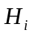 of G-s contains a tree spanner such that there is a vertex 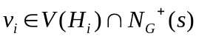 that reaches every vertex of through arcs of .
PROCEDURE TREESPANNER(G,T);{Find the tree spanner T of an acyclic digraph G.}
Begin
- t← the trival tree consisting of a vertex n;
- for i ← n-1 downto 1 do
3. ←{H|(H is a connected component of 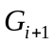) (V(H) 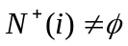);
- for each H do
- 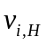 ← min{j|jv(H) 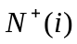};
- if reaches every vertex in V(H) though arcs of T
- then T←T+(i, )else output “No”EXIT;
end for;
end for;
- return T;
end TREESPANNER.
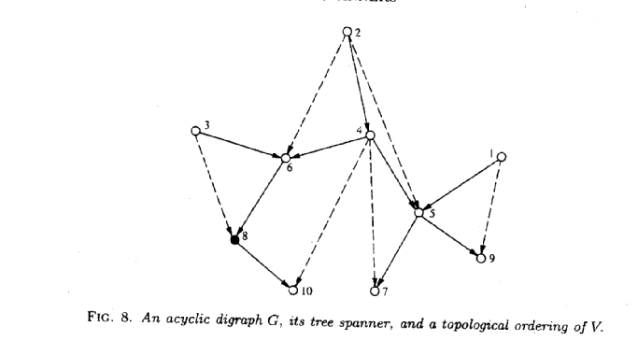 ALGORITHM TREE-SPANNER(G, T, t) {Find the tree spanner T of G.}
Input: A weighted digraph G = (V,A,w),
Output: The tree spanner T and its stretch index t if G admits a tree spanner; otherwise output "No".
begin
1. if G is not acyclic then output "No" EXIT
else compute a topological ordering of G,
{Vertices 1,.., n is a topological ordering of G.}
2. T ← the trivial tree consisting of vertex n,
3. Create set {i} for each vertex i of G,
4. for i ← n-1 downto 1 do
5. ←;
6. for each out-neighbor k of i do
{Compute{H|(H is a connected component of {/\(V(H) )}.)
7. Find the set Hk containing vertex k,
8. ←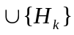};
end for;
9. for each set H do
10. ← min{jlj is an out-neighbor of i in H};'
11. T←T+(i, ),
end for;
12. Merge {i} and all H into a single set;
end for;
13. if T is a tree spanner
then compute the stretch index t of T
else output "No";
end TREE-SPANNER.
THEOREM 5.4. The minimum tree spanner of a weighted digraph and its stretch index can be computed in 0((m + n) (m + n, n)) time,where is a function inverse of Ackermann,s function and,for all feasible large m and n, (m,n) 4.
5.2. Quasi-tree spanners in digraphs.
LEMMA 5.5. Let T be a quasi-tree t-spanner of G. If both arcs (x,y) and (y,x) belong to G, then (x,y) A(T) iff (y,x) A(T).
LEMMA 5.6. lf T is a quasi-tree t-spanner of G, then is a tree t-spanner of .
THEOREM 5.7. For any fixed t > I, it is NP-complete to determine whether weighted digraph contains a quasi-tree t-spanner, even if all arcs have integral weight
THEOREM 5.8. For any fixed t 4, it is NP-complete to determine whether an unweighted digraph contains a quasi-tree t-spanner.

THEOREM 5.9. The quasi-tree 1-spanner of a weighted digraph can be found in 0(mlog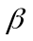(m,n)) time.
THEOREM 5.10. A triconnected digraph G admits a quasi-tree 2-spanner iff it contains a universal vertex u such that, for any intermediate vertex v cf G-u, both (u,v) and (v,u) are arcs of G.
HEOREM 5.11. A quasi-tree 2-spanner in an unweighted digraph can be found in linear time.

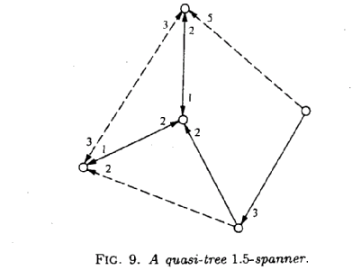

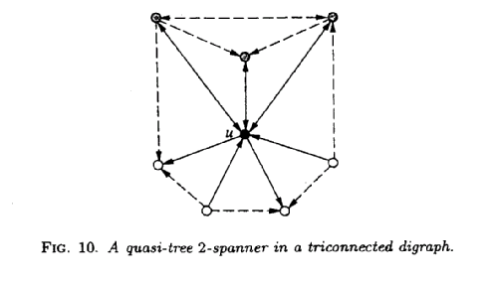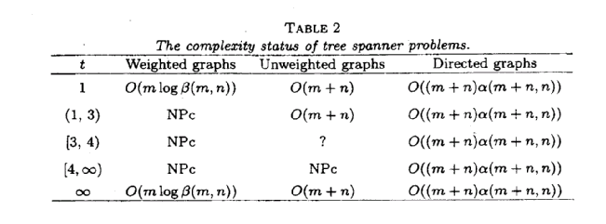
\

Created by : Shine-Hyue Wu
Date : Dec. 11, 2001

